West Hull Ladies
RRC

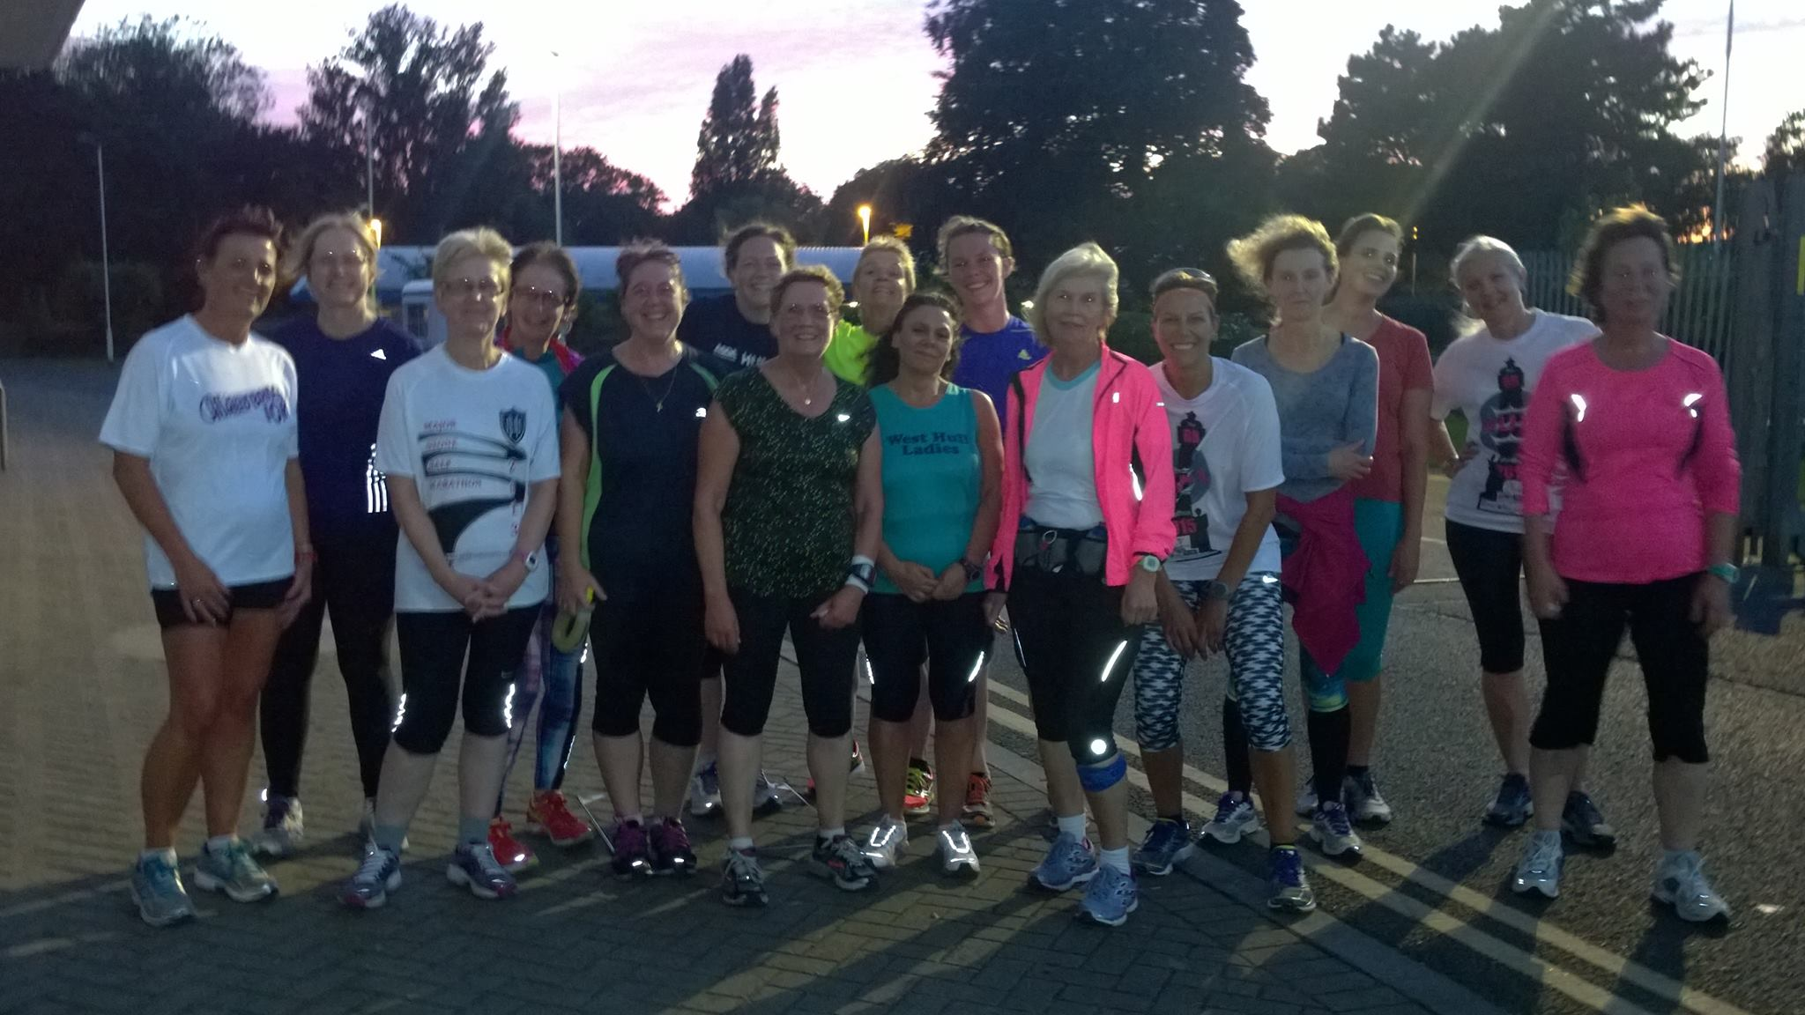October Newsletter

West Hull Ladies

WEST HULL LADIES RRC COMMITTEE MEETING
5th October 2015
Minutes
Present - Rachael L, Andrea, Karen, Anna, Amanda, Sandra, Jill, Maria, Zoe, Liz D, Jan.

- Apologies were received from Annette and Linda
- Minutes of the previous meeting were agreed.
- Matter arising - all matters from the previous meeting had been dealt with.
- Spoke about courses for Nutrition and Marketing that Sarah K had circulated. Jan to look into attending course on nutrition.
- Discussion about Club premises. As insufficient detail at this time was known this item to be placed on the agenda for later meeting.
- Amanda reported on the Hull marathon survey she had asked members to complete. Results of this were to be forwarded to Phil Haskins the organiser along with a copy of our marathon newsletter. Feedback concerning lack of food in the goodie bag and problems with the route at Sirius College also to be forwarded.
- 0-5k. Amanda gave details of what was required to get this running. Liz volunteered to advertise the course and Anna and Jill volunteered for other tasks relating to the distribution of information via the clubs email.
- The committee to put out email in relation to the Club place for the London Marathon explaining who was allowed to join the ballot.
- AOB. Liz informed the Committee that the Club banner had arrived. Karen stated that we were now recognised as West Hull Ladies by England Athletics.

Meet a Member: Liz H

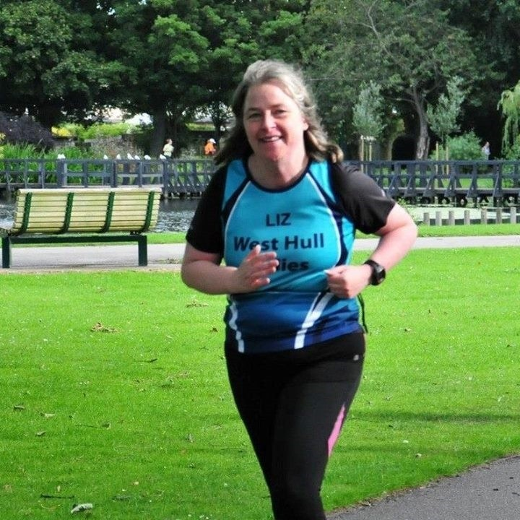
Name Liz Hobson
Age 48
Member of WHL: January 2015
What do you do when you’re not running? – Wife to Chris, (or is he husband to me?), mum to Hannah and work part time, member of Elite Horse racing club, have an interest in most things but particularly history.
How long have you been running? - 18 months
Why did you start running? - It kind of happened as a result of Chris becoming ill with diabeties, while he was in hospital we decided that he should get fitter. He then built a gym (shed) in our garden, with a treadmill and exercise bikes among other things. I decided that I ought to make use of the gym and started treadmill walking and running. I remember the first time I put together half a mile on the treadmill was when Jill (Jameson my big sister) ran her first marathon. I jokingly posted on facebook that Jill in running 26 miles had inspired me to run half a mile on the treadmill, I thought that Jill would laugh and joke at me but all I got was wonderful encouragement, this inspired me, eventually I got it up to a mile, and got up the courage to run outside which was quite a big issue at first! I had no plan I just kind of fell into it.
Favourite distance – At the moment I really love 10km races but am open to any distance that I haven't yet tried! Also starting to enjoy triathlons.
Favourite bit of running kit: My West Hull Ladies Vest I just feel so proud to be part of such an epic club!
Any injuries? - Touch wood not too bad. A dodgy hip last year and general niggles but nothing too serious.
Running goals? – a Marathon (Chris once bet me, when I was the biggest couch potato in the world, that if I ran and finished a marathon he would run down
Whitefriargate on a Saturday afternoon, bare arsed, I've never forgot this)
Proudest moment running related or otherwise – Doing the North Lincs Half Marathon, also proudly watching my daughter's play at Wyke, which she wrote and directed, also I hand carved a full size vintage Rocking Horse, which stands proudly in our front room window.
Best piece of advice you’ve received – Rest days are as important as training days!
Running alone or with friends? – I happily do both.
What keeps you motivated? – I am naturally lazy and I need to have something to train for so I try to have races booked ahead.

Meet a Member: Fatma
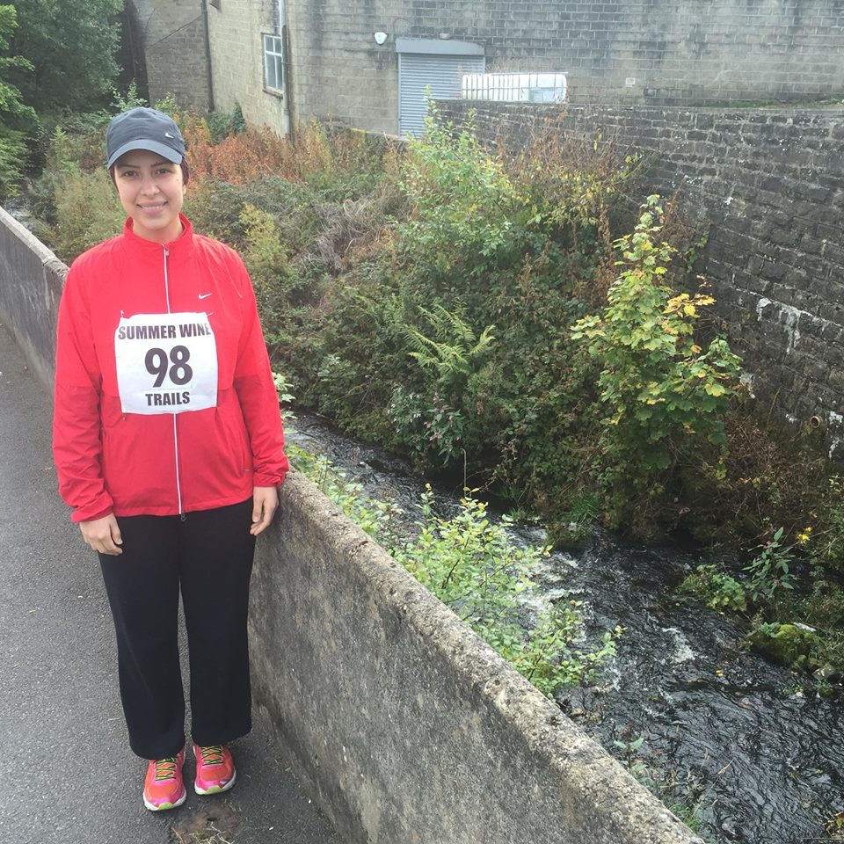
Name - Fatma
Age - 25
Member of WHL since – April/May 2015 (newbie)
What do you do when you’re not running? – ( work/hobbies/family) I work part-time and will study a course at the University of Sheffield starting in October. I am member of Xercise4Less gym and train there 3 x a week. I spend time with friends and family i.e. food / cinema and love travelling. My next destination is Portugal! I have a keen interest in photography, especially nature.
How long have you been running? - 2 years
Why did you start running? - To spend quality time with my husband. We first started running together which we really enjoyed and then entered Birmingham Half Marathon to raise money for charity. When I moved to Hull, I was searching for a ladies fitness club and WHL really interested me. So I decided to join! It has been the best fitness experience. The club is amazing, with a wide range of sessions and great support from the ladies. A few other reasons are: to keep fit, challenge myself and meet new people that share the same hobby/interest.
Favourite distance – 7 - 9 miles
Favourite bit of running kit - Asics trainers
Any injuries? - No
Running goals? – I want to increase my speed. The speed work training at the club is fantastic!
Proudest moment running related or otherwise – My first ever half marathon in 2013 finished it in 2 hours and 21 minutes. Humber Bridge half marathon 2015 finished it in 2 hours and 13 minutes.
Best piece of advice you’ve received – Keep up the positive work, great cause.
Running alone or with friends? – I have always run together with my husband and then joined the club.
What keeps you motivated? – The club and running for charity.

Berlin Marathon : Sandra

So I am not sure what I can say about the Berlin experience.
Things didn’t really go well for me from the start with injuries, holidays and lack of training. I managed a block of 4 weeks where I managed to get in some long runs and I had a lot of soul searching about whether I should actually run or not. In the end I decided to just go and run it and see what happened - although this is classed as a PB course for me to do that would be a miracle.
I left home on the Tuesday with my friend Gail to travel to the airport. We had an early flight to Berlin on the Wednesday.
Berlin is a walk able City and we certainly did that - we also did our obligatory cycle tour with Fat Tire Bike Tours. On the Saturday I was conscious that I should be resting so we hired bikes and went to the Olympic Stadium. I was in want of inspiration.
Sunday arrived and we left our apartment about 7am cycling to the start. This was a great idea - saved having to mess around with the subway. Gail then went back to the apartment (the route passed where we were staying at about 14km so great for her!)
I made my way to my start position and at that time there was hardly anyone there and importantly no toilet queues. The pen started filling up - I was in F pen, which was for runners with times bet 3.30-3.50hrs. One guy I was talking to told me that it was his first marathon. So unlike Boston, Berlin did not do checks on runners anticipated times? This is one of the reasons I believe there were problems with congestion in the race.
At 9am the first batch of runners were set off. At 9.15am it was our turn and we were walked to the start. The atmosphere at this time was very ‘carnival’ and everyone was singing and jumping up and down - and then we were off.
Initially it was okay - no different to the start of any mass running event but within a short space of time it became so congested with runners it wasn’t fun or enjoyable. The course has so many turns and some narrow streets that just caused us all to bunch. Runners were bumping into each other, running across the path of us each other and even pedestrians were weaving in and out of us. Sad to say that as I reached 11 miles I thought ‘ I have had enough of this”. There was no point in trying to push for a time - it just was not going to happen. I felt battered and bruised. So I queued for the toilet (not something I would normally do!) and then just ran to try and stay out of trouble. Not the race for anyone suffering from claustrophobia.
The drink stations supplied water, a herbal tasting warm tea, energy drink and apples and bananas. I did drink the tea and have bananas something I paid the price for at the end! But once again at the stations it was carnage, everyone barging through to get to the tables - the drinks came in plastic cups, which littered the floor. Not impressed!
About 21miles I could feel my legs starting to cramp - not good at the best of times but I was worried about coming to a sudden halt and then being trampled over! I took the sachet of salt I usually keep with me in a marathon. But then started to worry about getting to the next station to get a drink. I had missed one station earlier as I could not bear the thought of battling to get to it! Many people seemed to be cramping at this point and I am not sure if it was because of the stopping and starting we were doing. So telling myself to keep lifting my legs higher (this seemed to help!) I managed to go through the Brandenburg Gate to the finish. Once at the finish I felt so ill and made good use of a sick bag I was given. I think it was just the combination of tea, energy drink, gels and bananas. It wasn’t until several hours later that I was able to keep anything down. But I did manage to cycle back to the hire shop to drop the bike off and then walk back to the apartment. My arms felt bruised from being elbowed so much from people passing me and running across me.
The course did have many supporters out but I only heard a couple shout out my name, which is unusual, in most other marathons I have done spectators seemed to support everyone. A couple of English people passed me and made comment on flying the flag for Yorkshire. That was good to hear and it also made me realise how good it is to have West Hull Ladies on the back of our vests!
At the end and during the race I was just telling myself - no more marathons - sorry not even London Linda. However a few days later I came round from that way of thinking and am now looking forward to hopefully getting some good training in to go out and enjoy London.
I feel terrible saying that I didn’t enjoy the run but I didn’t - just too many people.
I have attached 2 photos to this report taken at 25km and 30km - you can see for yourself what the crowding was like. Afterwards I wondered if it was just me moaning again but these reinforce how crowded it was- not sure if you can spot me???
PS - the weather was marvellous!! Just right for running!
Shame I don’t use my maiden name of Walton or else I would have run a competition to “Spot Wally”
Sandra
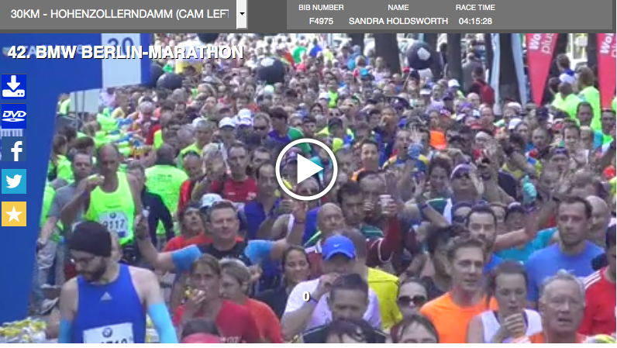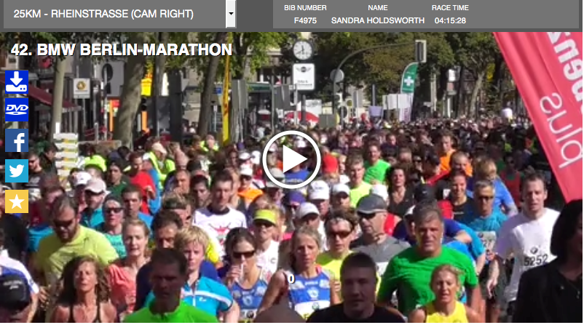

Hull Colour Run Write Up : Anna

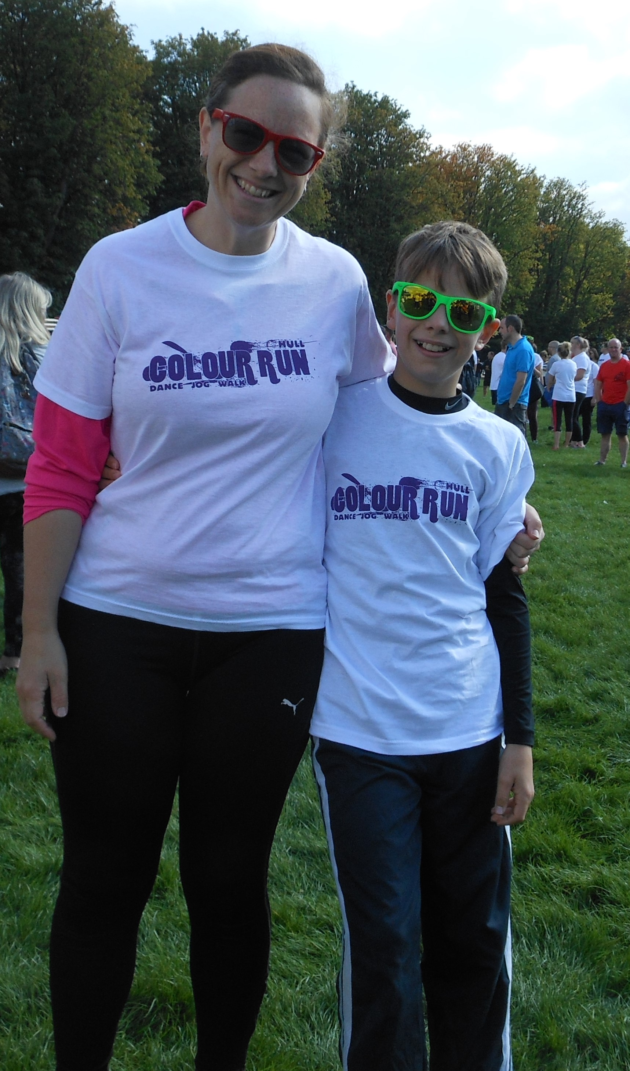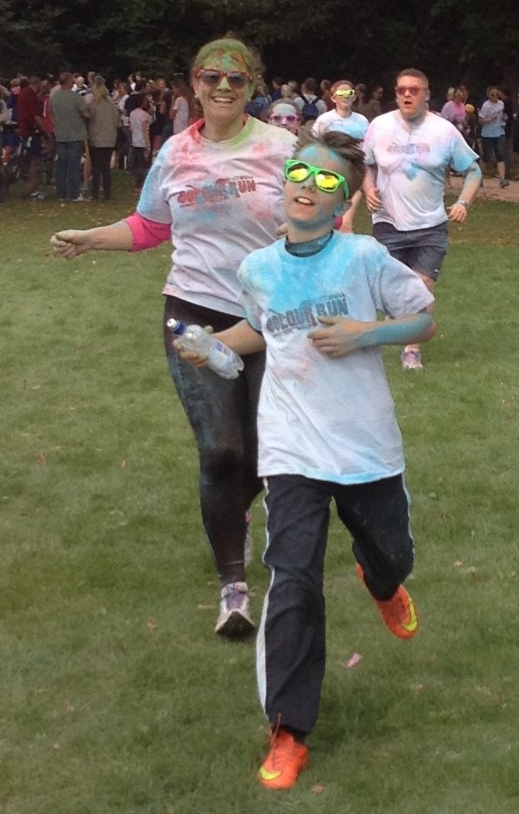
Before After

The Colour Run just sounded like it would be a bit silly, a bit of a laugh, and a chance for me to run with my son. It was all of those and, indeed, really colourful.
We gathered at the west side of the park, and were handed out a powder paint sachet with strict instructions not to open it yet- which most, not all of us adhered to!
Then, following a countdown, we all threw our paint in the air. It was amazing and incredibly surreal! I really could not see anything apart from Toms green sunglasses and his massive grin- magic. I had positioned myself carefully to get a mix of colours on my top (art college never leaves you). And we were covered- it looked fabulous.
They were staggering the start, and Tom and I were in the first batch. I was instructed to let him go on ahead- which made me sad, but I was happy that he wanted to do it.
Every kilometre there was a dye station- where you would be covered in paint- a different colour every time. We missed one due to not knowing the course. When you are used to the park run its hard not just to follow the route round East Park without thinking.
I caught up with Tom about half way round, and we did the second half together. (I did ask if I was allowed!) He managed with only a couple of walks and stopping for water- it was his furthest run so far. I loved chatting and running. It was definitely the kind of run for being sociable, in fact I met Sarah K in the second lap for a chat too.
It was lovely doing a silly run with no pressure. People walked, there were kids, and nobody would have known a time. There was a great crown to support too- and I would imagine it’s a good race for spectators- plenty to see and be involved in.
We are definitely getting a family ticket next year- lots of fun.
Just a warning- if they throw red paint at you, and you are sweating- you will look like you are running from the zombie apocalypse. Revolting!

Anna

Drax Sprint Triathlon Write Up : Jill

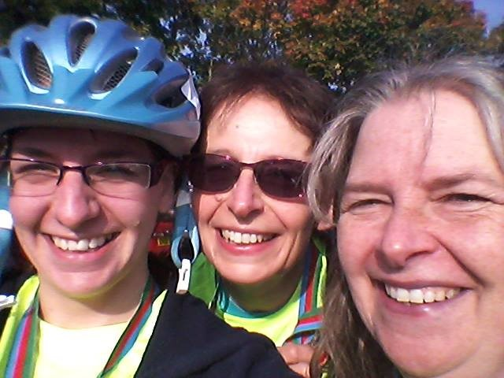

Our WHL Triathlon experience, started from a challenge from my sister Liz Hobson, who had already competed in a super sprint triathlon in April of this year. ‘How about it?’ she said having already entered the October Drax Sprint Triathlon. Never wanting to avoid a challenge, especially from little sis, I also entered. Daughter Zoe, not wanting to be left out, then got in on the act, despite the fact that she was travelling back from a three week holiday in Australia… with all the jet lag and all that!
As usual…I always think this is a good idea, until I really start to think about the reality of doing such an event. Whilst not being too worried about the 12 mile bike, and 3 mile run (although running straight after being on the bike is easier said than done, due to major Jelly legs, and possible cramp), the swim is a different matter. Not being confident in water is a major understatement for me. I hate putting my head in the water as it seems to get into every orifice possible, ending up with blocked ears for days afterwards. I hate being out of my depth, as I am scared that I will drown. I can just about do a length of breast stroke, and then have to stay at the side, gasping for breath and front crawl, which is the stroke of choice for triathletes, is a forlorn hope. The sprint triathlon however requires 16 horrible lengths of a 25 metre pool. So I really had to get into the swimming pool and sort out these issues. During my vacation from work in the summer, I kept threatening to go to the pool, but never really got there. In the end Zoe persuaded me to go and I decided that I really needed to go very regularly to be with any chance of either not drowning, or being embarrassingly rescued from the swimming pool! So for the two months running up to the event, I ended up going swimming at least three times a week. My swimming has certainly improved, so much so that I did have to get in touch with organisers to change my estimated swim time from over 18 minutes, to around 14 minutes. To put this in context however, the really good swimmers do the swim in 6 minutes, and the average seems to be around 10-11 minutes, so I knew I would be up against it right from the start. I was also worried about the myriad of rules that have to be followed to avoid elimination/penalty, the transition between the different events, and that I would probably forget something essential, such as my trainers, helmet or even my bike, in fact by the morning of the event I was a nervous wreck! Zoe on the other hand was so laid back having come back from a fabulous holiday in Australia that she was practically comatose …or was that the jet lag!? Putting the bikes and clothes in transition required numerous stickers, wrist bands, numbers and timing chips to be sited on the correct body part, bike, or piece of equipment. Helmets had to be put on, numbers and bikes were checked over. Space in transition was at a premium, so you had to set out your equipment in about a square inch of space. This was quite problematic as I had decided that having to ride a bike sopping wet, would require about three layers of clothing to be put on so that I wasn’t to suffer from exposure and frostbite, plus my trainers, gloves, helmet, glasses and bike shoes! Having put about three tons of talcum power in my socks and my clothes, I went to the swimming pool to await my swim start.
Goole pool is quite small only allowing four lanes to be used. I had been allocated to lane three, next to sister Liz who was in four (Zoe, who is a much faster swimmer was starting about 20 minutes later). The night before the event, me and Liz had already had the conversation about getting in and out of the pool, and I had sent a panicky email to the organisers: ‘Dear Jill, don’t worry, no you won’t have to dive or jump in as we will start you at the shallow end. Unless you are less than three foot in height, you should therefore be able to get your feet on the floor. Unfortunately we don’t provide a block and tackle to help you or your sister get out of the pool, but rest assured we have never yet had anyone stuck in the pool at one of our events, you will be fine. Kind regards ‘The organisers’. Names and numbers called out and into the pool with 30 seconds to go. I was terrified that I would lose count of the lengths, as I always seem to get lost after about 10 lengths. On the starting signal we started swimming. Because everyone starts in waves, the slowest first in this event, there were already three other people in each lane. Liz quickly showed that she was a much more competent swimmer than me, pulling ahead. I also nearly drowned myself at the first turn trying to get my feet on the floor and ducking myself under. It took me at least a couple of lengths to get my composure back rather than gulping air and moving like a demented frog on speed, but I just kept thinking dig in and keep going. By this point some faster swimmers had joined us in the lanes, some of whom proceeded to swim literally over me. One particular lad swam front crawl to overtake me, and then started to do breaststroke in front of me at a slower pace than I was going. I was quite annoyed at this, as it was certainly not a pretty sight under the water, and my thoughts to myself will not be repeated here as they were not at all polite to the young man concerned, suffice to say I did think ‘I’ll get you on the bike and run matie’! (As you know, I am not a competitive person at all lol!). I did keep count of my lengths okay and I knew that Liz was just under a length ahead of me and I was relieved when I saw her get out of the pool when I expected her to do so. Swimming to the end in relief, I managed to climb out of the pool relatively easily, and run into transition. Getting to my bike, I dumped my goggles and swim hat and put my glasses and helmet on, as if you touch your bike without a helmet on you get a penalty. I towelled my legs, and then put my cycle jacket on, disappearing in a cloud of talcum powder. I managed to get my compression socks on, which required me taking my timing chip off and then putting it back on. I then tried to put a pair of leggings on but gave up deciding that freezing to death was preferable to hopping around transition like Tigger trying to get the leggings on. Adding my gloves and number belt, I grabbed the bike and ran to the mounting line being careful to get on without incident, having previously been the only person to fall off in transition during a duathlon. Riding my bike, I took in a square of energy flapjack and put it in my mouth only to find that I had strained my jaw in the swimming…yes you have read this right…strained my jaw! This meant that I couldn’t chew the flapjack without it being quite painful, and ended up with it caked both in and around my mouth!
Anyway, apart from this, the bike went quite well, with only one guy passing me (a fast man with tri-bars!), whereas I managed to pass quite a few people. I saw Zoe on her way out, when I was on my way back in, and very soon I got back to transition where I changed into my trainers, removed my cycle jacket and helmet and started on the run. Having done some transition practice at home before the event, and having started the pseudo-run wearing my helmet on a number of occasions, I was pleased that I had not done the same in the actual event. The run followed the river bank and the concrete path turned to a grassy one part way along. My jelly legs, from getting off the bike, stayed for about half a mile, but then settled down. I quite enjoyed the run, but it did seem to go on for ever before the turn point. On the way back I saw Liz and then Zoe, but soon I was going up the finish line. I was really pleased with my time which was 1:22:44 (including Swim 14:38; First transition 2:17 (what were you doing having a picnic????); Bike 38:08; Second transition 1:09; Run 26:32. I was a bit fed up with hurting my jaw as it spoilt the experience of eating my mars bar, as I had to nibble it like a squirrel rather than chewing great chunks off it, which was a bit of a pain as I only eat mars bars after running events, so normally this would be a bit of a treat. ☹. I was able to cheer Liz and Zoe in through the finish, both of them doing great times. Would I do a triathlon again…well I’ve bought a bloody tri-suit, so I suppose I need to get some wear out of it, but I REALLY NEED TO SORT OUT MY SWIMMING!!!!!
Jill

Drax Triathlon Write Up : Zoe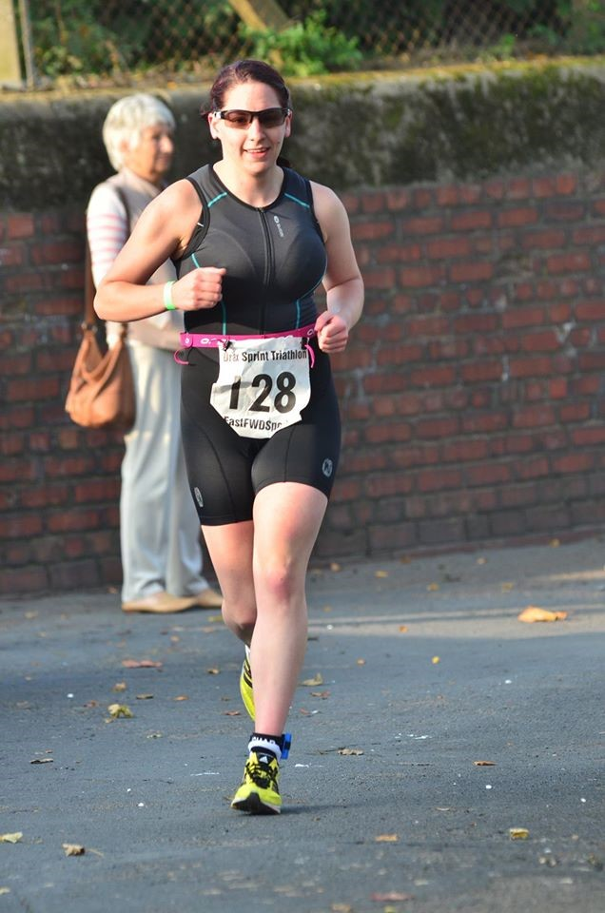

I recall several years ago discussing triathlons with other club members and saying that I would never enter one because I didn’t like the idea of getting onto my bike dripping wet through. However, after Aunty Liz (Liz H to everyone else) talked mum into entering the Drax triathlon I started to feel rather left out. And after dragging mum to the swimming pool to practice, I suddenly remembered how much I enjoyed swimming.
The reasons not to enter: cost for buying both a tri suit and the race itself, the fact that I had to get onto a bike dripping wet through, it would be only two days after returning from Australia so I would probably have jet lag and the fact that it was in October and would therefore be cold.
The reasons to enter: I couldn’t let mum beat me to it!
I therefore entered the triathlon and started doing some swimming (I hadn’t done any swimming for at least 7 years so needed the practice). I needed to get some training in before going on holiday as I would not get chance to do any cycling.
I went off on my 3 week holiday to Australia intending to do some practice but of course this didn’t really happen. I managed to go in a small pool several times but couldn’t really do any lengths and I did a 2 mile run in Cairns (it was just too hot!) and a parkrun in Perth.
On race day I was feeling very tired and dreading the cycle as I hadn’t done any practice at all. The other thing that I was nervous about was counting my lengths in the pool as I had lost count on every practice session.
The swim started off OK but I seemed incapable of swimming in a straight line. I then tried to go too fast and inhaled half the pool which resulted in me losing confidence and doing my last 3 lengths in breaststroke which slowed me down. I was happy to get out of the water and get to my bike.
I set off on the bike with jelly legs and spent the first half of the bike ride trying to calm myself down. I didn’t really push the cycle as I wanted to save some energy for the run and felt a bit light headed getting onto the bike. I was looking forward to the run and felt like I was struggling on the bike – that was until I started running then wished that I was back on my bike again.
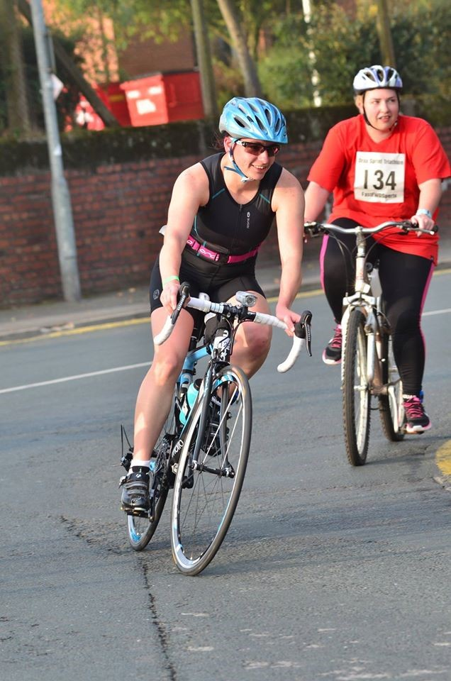
My legs were like lead on the run and I felt like I was going at a snail’s pace. However, I was passing people so this gave me confidence. I ran past mum who was on her way back from the turning point towards the finish (she started before me) she told me that I was catching Aunty Liz so I concentrated on my style and tried to keep my cadence high. It seemed to take forever to reach the turning point but my legs felt better in the second half. I kept passing people and only two men passed me in the final 2.5K. Coming into the finish I managed a sprint and suddenly felt like my legs were working again. If only they had done that at the start of the 5K!
I finished in 1hr 19min 3sec which was good considering the lack of practice. And the important thing was that I beat mum!
Note to self for next time (Yes there will probably be a next time as I will want to improve on this result!): PRACTICE
Zoe

Training & Energy Systems
A simplified description by Amanda

Training is essential to enable our bodies to adapt to be able to run further or faster. Training varies from social running to quality sessions and each improve our bodies in different ways. Hopefully, the below will help you decide what you need to focus on in order to achieve whatever your goal may be from simply enjoying a run to getting a race PB.

In the description below the energy systems are targeted in terms of percentage of your maximum heart rate. On average this is 220 minus your age but this varies from person to person and is dependent on fitness levels. You can used perceived efforts so where it says 80% this would be what you consider to be an 8 out of 10 effort.

The description uses some technical language and I have added a Definitions section at the end to help. Hopefully, like me, once you understand the physiology of the training you can then appreciate why you do it and enjoy your training even more.

Endurance Training - Essential
It increases blood volume and red blood cells which transport oxygen to your working muscles and creates a greater capillary network for more rapid diffusion of oxygen to your muscles. It stimulates the storage of more fuel (glycogen) in your muscles and increases the use of intramuscular fat to spare glycogen. It increases mitochondrial density and the number of aerobic enzymes within the muscles which is where aerobic metabolism takes place. Surprisingly, once your slow twitch muscles are fatigued you will enlist some of your fast twitch muscles.
Aerobic training should be 65-75% of your maximum HR i.e. you will be feeling quite comfortable. This focus is on getting quantity of miles each week and includes your long runs.
Note, there is an upper limit to this adaption which is unique to each person. E.g. running 60 miles per week might not make you perform any better than running 40 miles.

Acidosis (Lactate) Threshold Training
Training AT increases the speed at which acidosis occurs enabling you to run at a higher percentage of your VO₂max for longer. It enables you to go faster before oxygen-independent metabolism begins to play a significant role. With training what was an anaerobic pace becomes high aerobic, which simply means it allows you to run at a faster pace for longer.

AT training should be 80-85% of your maximum HR (around 5K-10K race pace effort - you cannot chat). The point is to raise your blood lactate level to just below its threshold and maintain it. Work outs are for a significant length of time 15 – 40 minutes or shorter with short recovery e.g. 4 minutes at 90% with 1 min recovery, repeat 6 times.
We do not target this very well at the club. In the past we have run some threshold sessions but they are not very sociable, however, it has been said that, especially as you get older, this may be the best form of training to achieve results. The Fast K and Fast Mile training come close and you will be able train at threshold by running with people who are a little faster than you … they will be chatting, you will not!

(VO₂max) Interval Training
Increases the number of mitochondria and enzymes in the muscles. It involves high intensity followed by sufficient time to recover. During recovery HR declines quickly but initially a lot of blood must return to the heart. It takes longer to fill left ventricle which results in a brief increase in stroke volume which places overload on the heart. It is the recovery interval which stimulates the maximum stroke volume and increases the capacity of the oxygen transport system.
Interval training at an intensity that achieves at least 95% max HR during each work period, you are working hard. It is one of the best methods for improving cardiorespiratory conditioning. Work periods 3-5 minutes with equal recovery or short periods such as 2 mins with 1 min recovery.
Hill Training is effective for cardiorespiratory because your heart rate can easily rise to its maximum and increases leg muscle power. In addition the 400M reps, 10’ Intervals and Stadium reps if you work hard are also effective.

Anaerobic Training – sprinting
During anaerobic sessions muscles quickly lose the ability to contract effectively because of the increase in hydrogen ions causing acidosis. Enzymes that break down ATP (energy) are inhibited, the release of calcium and production of ATP from glycolysis is inhibited resulting in the decrease in contractile force. i.e. although you start fast, you quickly get slower.
Anaerobic training causes acidosis which stimulates your muscles to adapt thus increasing your anaerobic capacity. It improves the ability to regenerate ATP via anaerobic metabolic pathways.
Interval training at an intensity that achieves max HR during each work period. Work period 30s-1 min with recovery up to 3 times the work period. What is important is you work at full capacity.
You could achieve this type of training during the ‘Friday Thresholds’ (misnomer) where you run hard for 30s, then recover and repeat. You have to be willing to give everything.

Definitions
Your Maximum Heart Rate. The highest you can get. Finding your Max HR: it is suggested you work hard for 3 mins followed by 1 min recovery, repeat. You will probably get your Max HR on the second or third effort. You obviously need a heart rate monitor and device to capture this.
ATP Adenosine triphosphate is the energy molecule found inside muscles. Only a small amount is stored so it is constantly resynthesized. It is very important during racing to be able to reproduce it quickly.
Energy Systems
- Aerobic system: Dominant in everything over a few minutes. (ATP is created from blood glucose, muscle/liver glycogen and fat. 1 molecule glycogen produces 38 ATP, 1 molecule fat produces 130 ATP).
- Anaerobic system: All out run for 30secs-2mins (ATP is created from glycogen from the blood or muscle but not enough oxygen for your needs. 1 molecule produces 2 ATP)
- Phosphogen system: All out sprint, fuel used up in 30 secs (ATP is created from CP (creatine phosphate) in the muscles. 1 molecule produces 1 ATP).
All three used in various amounts depending on effort.

Muscles
They work by releasing calcium to trigger contraction.
- Slow twitch muscle fibres contain a large network of capillaries to supply oxygen, myoglobin to transport oxygen, mitochondria providing aerobic metabolism.
Muscles contract slowly but can go for hours.
- Fast twitch A and B muscle fibres: strength, speed, power due to large stores of CP, glycogen and anaerobic enzymes.
Muscles contract quickly, fatigue quickly. B = sprints. A = long sprint.
It’s thought you cannot change what you are born with but training enhances the fibres that you want to use.

Lactic acid is immediately changed to lactate. An excess is only produced when working above Acidosis (Lactate) Threshold. Excess lactate is transported by microscopic proteins to the heart and liver where it is converted to fuel. Soreness in muscles is caused by microscopic tears, not lactic acid.
Acidosis (Lactate) Threshold fastest speed you can sustain aerobically (sub-metabolic acidosis).
VO₂max - maximum volume of oxygen your muscles can consume. Thought to be the best indicator of person’s aerobic fitness.
Cardiovascular stuff: The stroke volume is amount of blood and how fast it can be squeezed from left ventricle and how quickly deoxygenated blood is returned to the heart.
‘Cardiac Output’ is the stroke volume multiplied by the heart rate. The bigger the better.

Park Run stats- September

A total of 40 park runs were completed by West Hull Ladies. (that’s 120 miles)
There were 5 P.Bs totalling 76 seconds
Park Run tourists- Suzanne @ Southampton, Zoe @ Canning river, Perth.

Fundraising News: Sandra

I am running 3 marathons for Crohns and Colitis UK.
So far I have completed Boston (April 2015) and on the 27th September 2015 I shall be running Berlin and in April 2016 London. Having run York in October 2014 I will by the time I have finished run a marathon every 6 months. As many of you know the hard part of the Marathon is the training and I can tell you that is does not get any easier. However when I am running I do think of what I am fundraising for - no matter the hard work it is nothing in comparison with what sufferers of this disease live with everyday.
Why did I pick Crohn's and Colitis?
It was a massive support to me when my daughter was first diagnosed with Crohns just after I ran the London Marathon in 2012. For an adult it is a horrible chronic (lifelong) disease but for a teenager it can be overwhelming and it is certainly life changing. Your health is never something to take for granted.
The charity works to support all those affected by inflammatory bowel diseases to achieve a better quality of life, improve services and ultimately find a cure.
More and more young people are being diagnosed with the disease and I feel that the charity needs all the help it can get not only to try and find a cure but to raise awareness. Most people can look well on the outside but they are far from that.

Any donations would be gratefully accepted - every single £1 would be of a great help.
I do have a justgiving page if anyone would like to make a donation
www.justgiving.com/Sandra-Holdsworth/
Many thanks
Sandra

Fundraising News: Tracy

As most of you know I run alot, I'm a member of an amazing running club, which is WHL (West Hull Ladies). I joined this club August 2014 never thinking that 1 year on I would be running a marathon! The support & encouragement from this club is amazing, I wouldn't have got this far without them.
Running a marathon is something that's always been on my 'bucket list'. Through all the hard work in training to marathon level I've decided that I would like use this opportunity to raise some cash for a worthy cause ... Cancer Research UK - a charity that is always in need of more cash to help find a cure for this dreaded disease.
I'm sure you know someone who has suffered from cancer and that's why I'm asking for your help in raising as much as I can for a great cause!
Please give what you can afford.
Cheers guys
Tracy x

Link is : https://www.justgiving.com/TracyToner-HullMarathon/

Social Event: Tracy
A date for your diaries ladies - my special birthday night out (50th ), Saturday 14th November (birthday is the 20th), not sure where yet but probably Prinny Ave unless anyone has got a better idea. Let me know if you're interested. I think we all deserve a good night out after all the training we've put in this year.
Tracy x

2015 RACE DIARY
http://westhullladies.org.uk/races.htm

Free 5K time trial every Saturday 9am: Hull Parkrun or Peter Pan Parkrun Humber Bridge parkrun

October 2015
 | 4th/09:30 | Huddersfield Hilly Half Marathon | £20 | Online entries only | online entry
 | 11th/10:00 | Yorkshire Coast 10K | Race Full | Race Full | Race Full
 | 17th/11:00 | Gruesome Twosome Half Marathon | £19 UKA/£21 | Entry form | Postal entries only
 | 18th/10:00 | Bridlington Half Marathon | £13.50 UKA/£15.50 | Entry form | online entry
 | 25th/11:00 | Brigg Poppy 10K | £15 UKA/£17 | Online entries only | online entry
 | 25th/11:00 | Haltemprice 10K | £7 UKA/£9 | Entry form | Postal entries only
November 2015
 | 1st/TBC | Deep Dale Dash | £15 UKA/£17 | Online entries only | online entry
 | 1st/10:30 | Guy Fawkes 10 Mile | £14.70 UKA/£16.70 | Online entries only | online entry
 | 8th/11:00 | Dalby Dash 10K | £11 UKA/£13 | Online entries only | online entry
 | 15th/09:30 | Leeds Abbey Dash 10K | £22 UKA/£24 | Online entries only | online entry
Please remember to double check dates, times and entry fees with the official website or the entry form. Zx Keep checking the website for new races and updates.

NOTE: Club Vests must be worn at any races you enter
under the West Hull Ladies running club name.
West Hull Ladies Road Running Club
Kit Order Form

NEW STYLE VESTS are purchased direct from www.pbteamwear.co.uk
On website: click on Clubs, Athletics Club, West Hull Ladies RC
Pick your size, name you wish to have on the front and follow payment instructions

For all other purchases use this form.

FORENAME ___________________________________
SURNAME ___________________________________

ORDER - tick what you require and circle your size Price
- OLD STYLE VEST SIZE 10 12 14 16 £10.00 (useful for training)
- LONG SLEEVED SIZE 10 12 14 16 £18.50
- HOODIE SIZE XS S M L £20
- HOODIE with ZIP SIZE XS S M L £20
Note on size: M is approximately size 14

- BEANIE HAT £6.50
- PINLESS WHL NUMBER FASTENERS (set of 4) £3.00

DATE Ordered _______________
AMOUNT PAID _______________

Please transfer payments online with your name and marked as ‘Kit to:
Account: 63762742 Sort Code: 20 43 49

Or cheque payable to ‘West Hull Ladies RRC’, and write your name and ‘Kit’ on the back and give to Club Treasurer Linda Dodsworth, 110 The Stray, South Cave, E Yorkshire. HU15 2AL

Sign on receipt of goods _________________________________
DATE _______________

Please complete this form and email to diazmaria@btinternet.com
Thanks.
Maria Kit Officer

